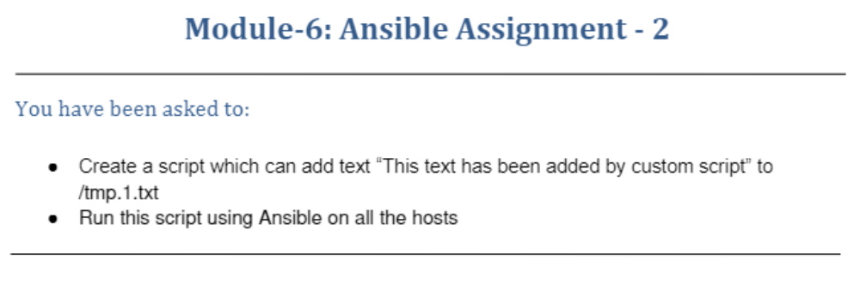
Inventory File created for two slaves
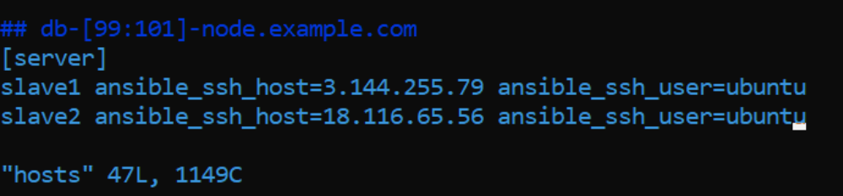
ubuntu@ip-172-31-1-80:~$ mkdir ansible
ubuntu@ip-172-31-1-80:~$ cd ansible/
ubuntu@ip-172-31-1-80:~/ansible$ sudo vi playbook.yaml
ubuntu@ip-172-31-1-80:~/ansible$ sudo vi playbook.yaml
ubuntu@ip-172-31-1-80:~/ansible$ ansible -m ping server
[DEPRECATION WARNING]: Distribution Ubuntu 20.04 on host slave1 should use /usr/bin/python3, but is using /usr/bin/python
for backward compatibility with prior Ansible releases. A future Ansible release will default to using the discovered
platform python for this host. See https://docs.ansible.com/ansible-
core/2.11/reference_appendices/interpreter_discovery.html for more information. This feature will be removed in version
2.12. Deprecation warnings can be disabled by setting deprecation_warnings=False in ansible.cfg.
slave1 | SUCCESS => {
"ansible_facts": {
"discovered_interpreter_python": "/usr/bin/python"
},
"changed": false,
"ping": "pong"
}
slave2 | SUCCESS => {
"ansible_facts": {
"discovered_interpreter_python": "/usr/bin/python3"
},
"changed": false,
"ping": "pong"
}
ubuntu@ip-172-31-1-80:/etc$ cd /etc/ansible/
ubuntu@ip-172-31-1-80:/etc/ansible$ sudo vi myplaybook.yaml
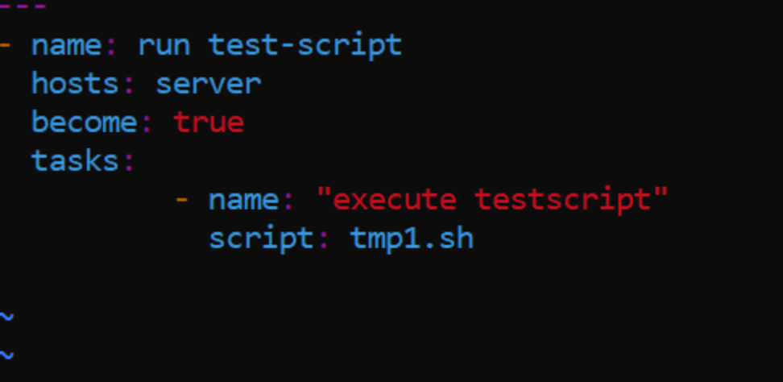
ubuntu@ip-172-31-1-80:/etc/ansible$ sudo vi tmp1.sh
ubuntu@ip-172-31-1-80:/etc/ansible$ sudo chmod -R 777 tmp1.sh
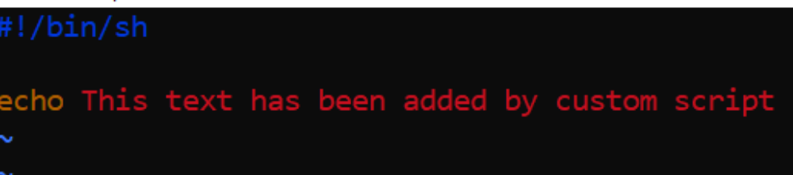
ubuntu@ip-172-31-1-80:/etc/ansible$ sudo vi myplaybook.yaml
ubuntu@ip-172-31-1-80:/etc/ansible$ ubuntu@ip-172-31-1-80:/etc/ansible$
ubuntu@ip-172-31-1-80:/etc/ansible$ ansible-playbook myplaybook.yaml

PLAY [run test-script] ***************************************************************************************************

TASK [Gathering Facts] ***************************************************************************************************
[DEPRECATION WARNING]: Distribution Ubuntu 20.04 on host slave1 should use /usr/bin/python3, but is using /usr/bin/python
for backward compatibility with prior Ansible releases. A future Ansible release will default to using the discovered
platform python for this host. See https://docs.ansible.com/ansible-
core/2.11/reference_appendices/interpreter_discovery.html for more information. This feature will be removed in version
2.12. Deprecation warnings can be disabled by setting deprecation_warnings=False in ansible.cfg.
ok: [slave1]
ok: [slave2]

TASK [execute testscript] ************************************************************************************************
changed: [slave1]
changed: [slave2]

PLAY RECAP ***************************************************************************************************************
slave1 : ok=2 changed=1 unreachable=0 failed=0 skipped=0 rescued=0 ignored=0
slave2 : ok=2 changed=1 unreachable=0 failed=0 skipped=0 rescued=0 ignored=0

